
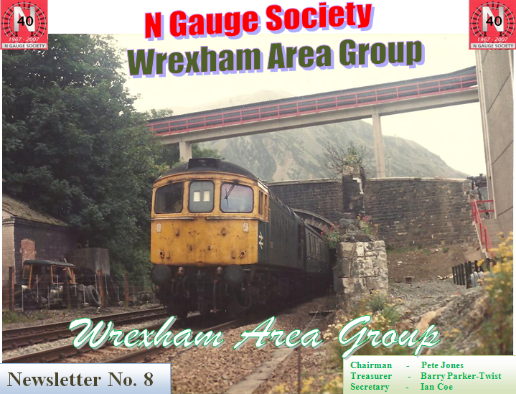
Class 33 heads the Bangor – Cardiff service through Penmaenmawr beneath the aggregate conveyor
Meeting held Wednesday 24th November 2010
at Maesgwyn Community Centre, Wrexham

With apologies received from John and Philip there were six members present – Roger, Ian, Kevin, Rowland, Pete and Lee. Ian had remembered to bring along the controller but no one had brought any stock.

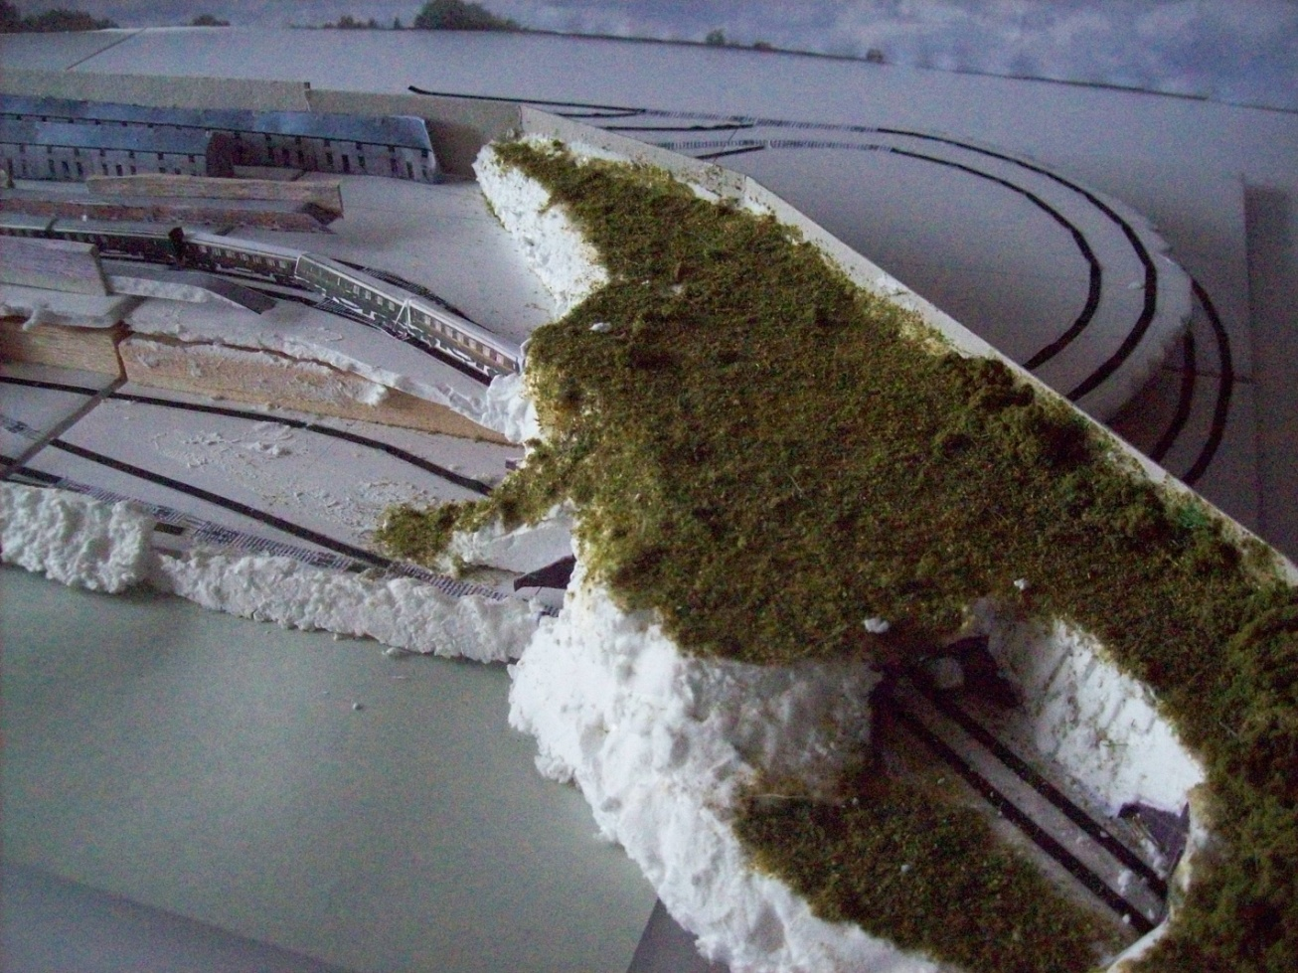
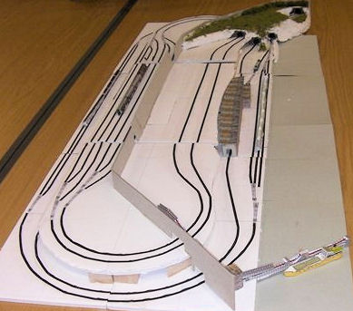
The main topic for the night was the design and building of the Group layout. Ian brought along a one quarter scale model of what had been proposed for members to have a look at. The revised layout allows for three long or six short trains to be run in each direction on the high level line and two separate low level freight lines which will both feature locos bringing in empty wagons and departing with loaded wagons but using different techniques.
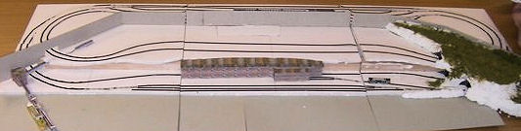
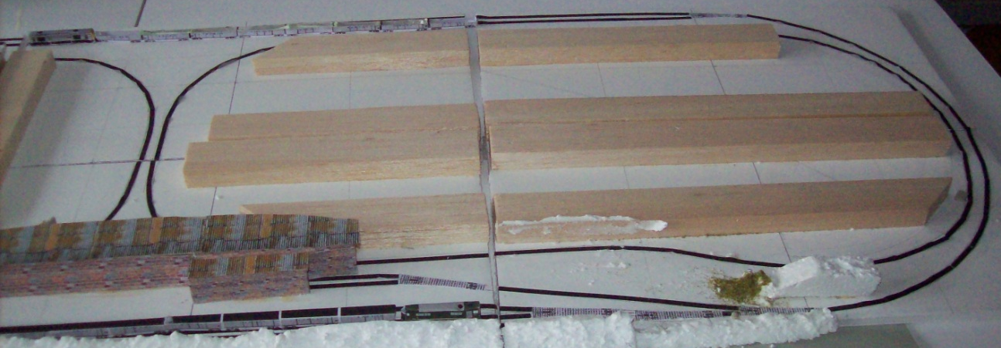
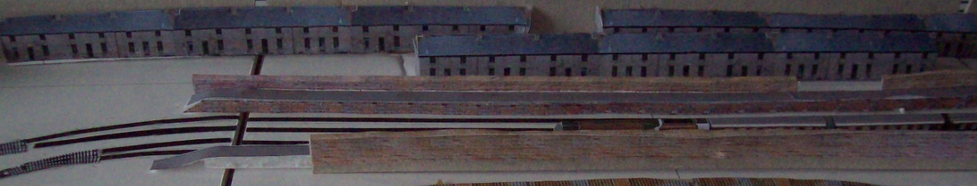

If built as per the model, five separate controllers will be required and probably six operators would be required although this could be reduced to four if necessary providing certain lines were left to run with “one engine in steam” or wired for automatic operation.
Chairman - Pete Jones
Treasurer Barry Parker-Twist
Secretary - Ian Coe
Newsletter N. 8
Several points were raised – some of which could be answered and others needing further consideration.

We felt that there would probably be enough depth in the layout to increase to four sidings for each high level line the accommodation in the fiddle yard and to have two through lines at the station with loops for stopping trains.

The ‘sea’ at the front of the layout caused some debate as to how best represent it. If we are to have a coaster loading at the quarry jetty then the tide should be in and the sea should not be rough. Suggestions included ripple Perspex, ripple plastic (from Germany – nice but expensive), paint and varnish and Ezewater. It will probably be a case of experimenting with various effects until we find one that satisfies the majority. If we use either of the latter methods, they will be best carried out outdoors in the summer, talking of which, Rowland asked whether the layout would be finished by the end of next year! Not much chance of that if we only meet for two and a half hours each month. Chester Group’s layout “Cragmill” took 3 years with weekly layout-building sessions! However there’s nothing like setting targets to get jobs done and we could aim to get the layout operational, if not scenically finished by the end of 2012.

A valid point raised was, “Where do we store the layout as it is being built and when it is completed?” No full answer to that yet but it will probably be a similar situation to the North Wales Group’s predicament before they moved to new premises. Each month the boards were brought to the meeting and afterwards taken back to members’ homes for storage. The ‘cupboard’ at Maesgwyn is not big enough and not secure enough to prevent damage being done to the boards in between meetings so it would be handy if at least four members volunteered to look after a pair of boards each.

The village section will be designed to lift out to ease carriage and deal with the unlikely event of a derailment on the low level line that passes beneath it.

Financing the building of the layout is an immediate concern if we are to order the timber and polystyrene for our next meeting. We obviously have funds at present (owing to Wrexham CBC’s failure to send us a bill for hall hire) but we should not spend this on the basis that they may never ask for money. Somebody there will realise sooner or later! We have the Society Grant monies due in shortly which will help offset the purchases but we need to set up a layout building fund and Ian set the ball rolling by bringing in a few surplus books and DVDs which he offered to members on the basis that they don’t pay him for them but make a contribution to the fund. Perhaps, after Christmas, there may be other unwanted gifts which could be brought along and “bought” by members in the same manner?

Ian took a trip to B&Q after the meeting to price up materials. The main building blocks are expanded polystyrene boards sold for wall and floor insulation and come in 8ft x 4ft sheets of 50mm and 100mm thickness at £23.99 and £43.99 respectively for the “moulded beads” type or a superior type which cuts without leaving a mess is available at £4.95 for a 4ft x 2ft x 50mm sheet. We would need one and a half 8ft x 4ft sheets or 12 of the 2ft x 4ft sheets (double thickness required – one for the base of the low level line the other for the high level line)


For the frames B&Q had 8ft x 4ft sheets of 18mm ply for £23.99 and surprisingly 6ft x 4ft sheets of the same material for £26.49 – which they claim is their “best seller!” We need 6off (2 x 4ft x 3ins) and 6 off (2 x 2ft x 3ins) = a total of 18sq ft so, in theory, the smaller sheet would suffice but it is more expensive. Hopefully Barry will find a better deal at his local timber merchant.
The diagram to the left shows the planned construction of the baseboards (showing the bottom side uppermost).

Two 4ft lengths of 3in wide 18mm ply are
butt joined to two 2ft lengths to form a frame
into which a 2in (50mm) thick slab of
polystyrene is fitted.

Two or three cross members of 1 inch deep 18mm ply are screwed to the base to support the polystyrene. A further 4ft longitudinal support, 1 inch deep may be added to provide a guide for slotting the board onto a trestle.

The discussion regarding the layout baseboards continued at the Chester Group meeting on the following Friday evening with Barry, Pete, Rowland, Kevin and Ian being present. We debated whether to have integral legs or to build separate trestles. The latter would have the advantage that we could adjust the viewing height of the layout.
Next meeting at Maesgwyn – Wednesday 26th January at 7:30 p.m.

